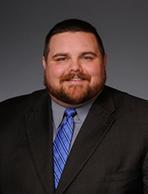
Rep Bob Ballinger-D97-Atty,
Hindsville, AR

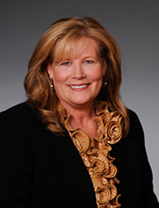
Rep Charlotte Vining Douglas
D-75-Retired, Alma, AR

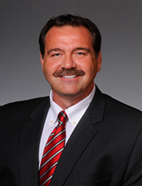
Rep Joe Farrer -D44-
Physical Therapist,
Cabot area (Austin, AR)

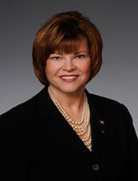
Rep Charlene Fite-D80-
School Psychologist,
Van Buren, AR
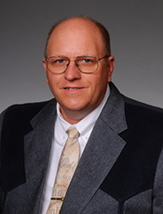
Rep John Payton D64
Auctioneer-Car Dealer-
Wilburn, AR

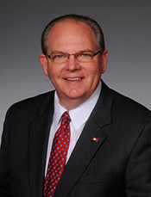
Rep Terry Rice Senator Elect
-SD9, Business Owner
(Furniture Store), Waldron, AR

Rep Josh Miller, D66,
Property Manager,
Heber Springs, AR

Sen Cecile Bledsoe D3,
Mgr Surgical Clinic, Rogers, AR
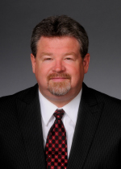
Sen Alan Clark D13, Building
Supply Business, Hot Springs
(Lonsdale, AR)

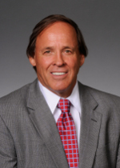
Sen Gary Stubblefield, D6,
Dairy Farmer, Branch, AR

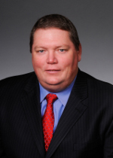
Sen Bryan King, D5, Farmer,
Green Forrest, AR

Sen John Cooper, D21,
Minister, Jonesboro, AR

